NEWS RELEASE
For Immediate Release:
January 7, 2026
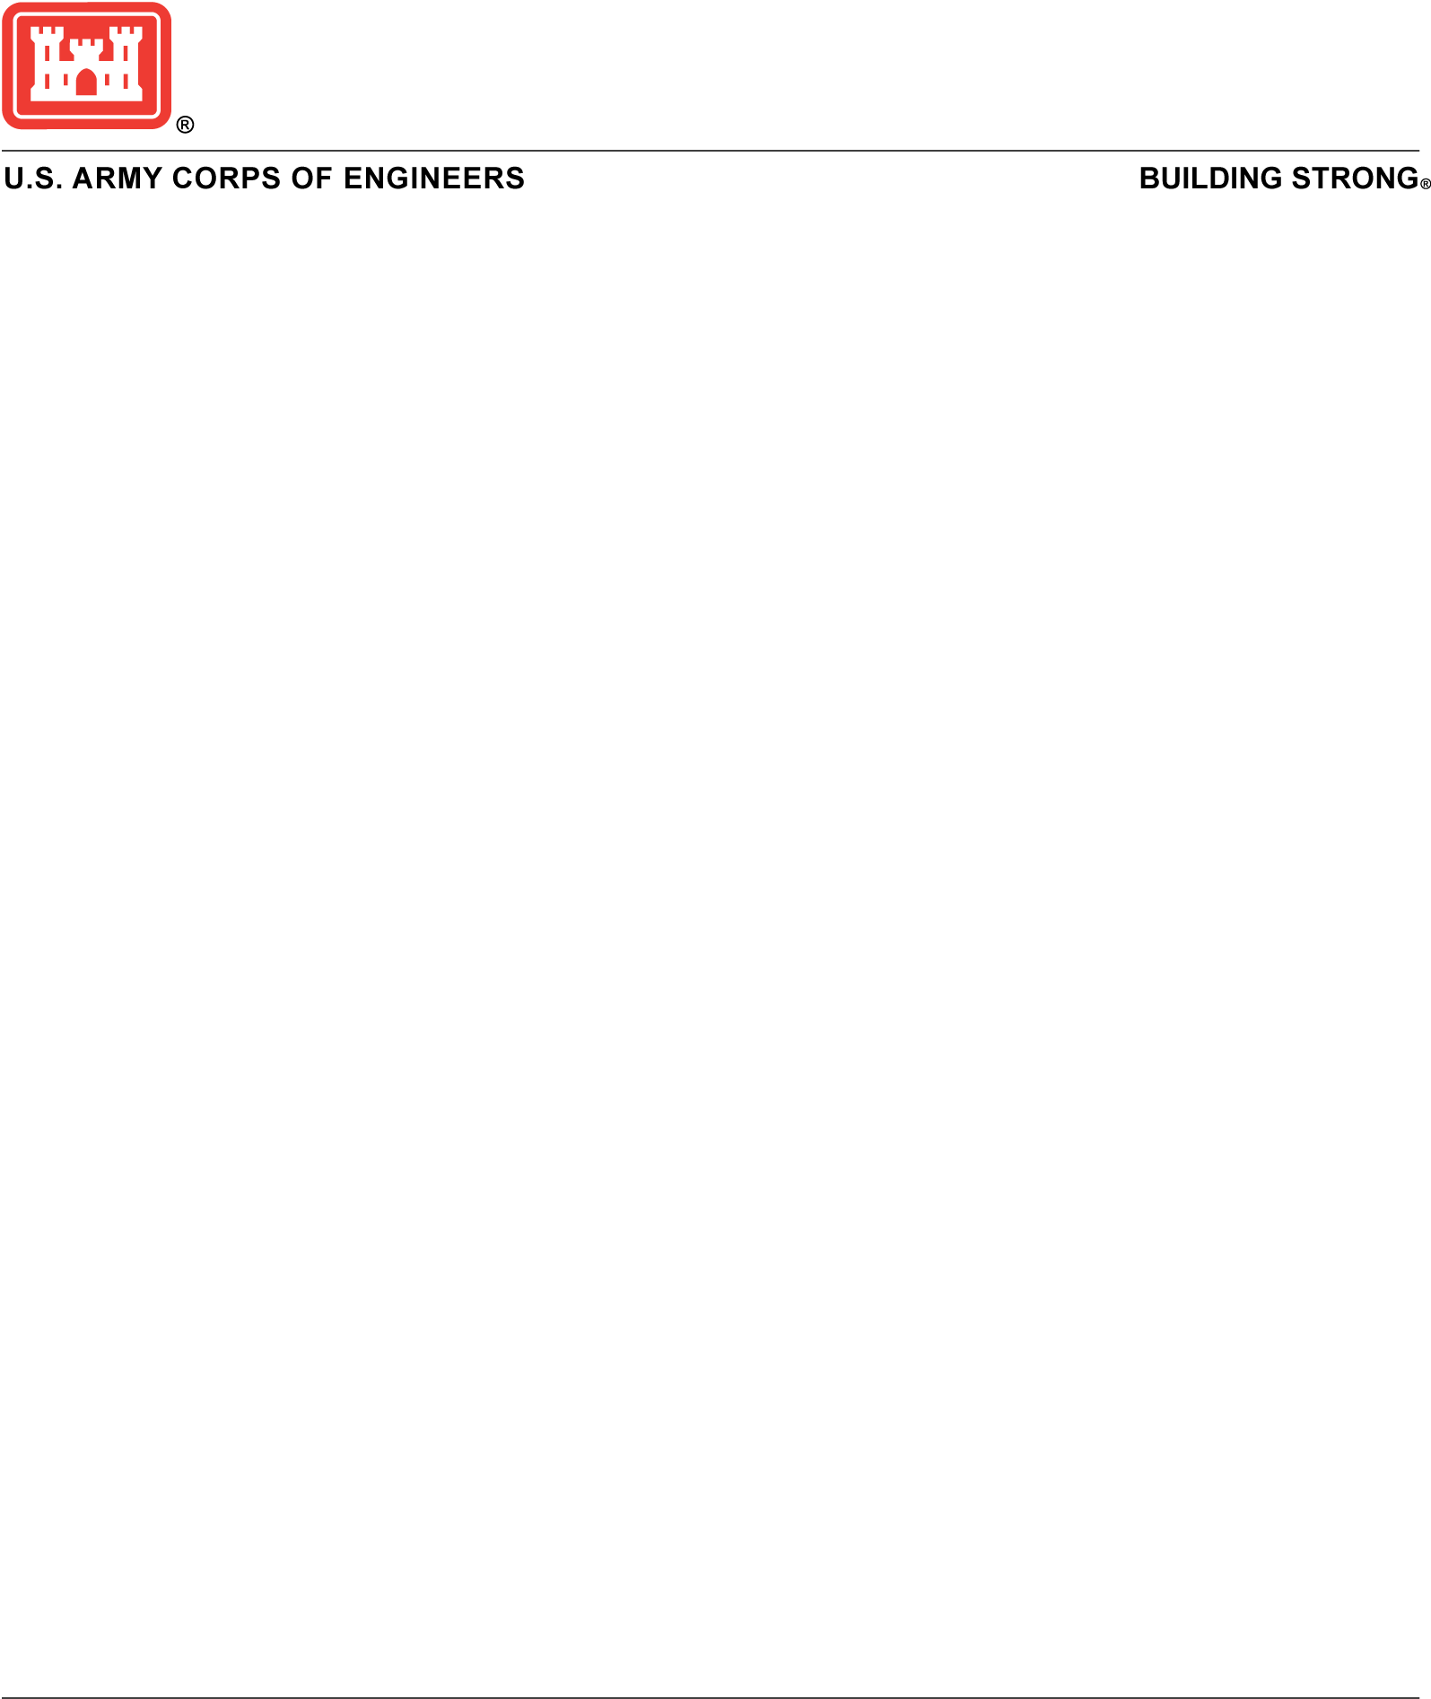
Contact:
Gene Pawlik 202-761-7690
Eugene.A.Pawlik@usace.army.mil
Doug Garman 202-761-1807
Doug.M.Garman@usace.army.mil

U.S. Army Corps of Engineers announces finalization of nationwide permits

WASHINGTON – The U.S. Army Corps of Engineers announced today that it will reissue 56 existing nationwide permits and issue one new permit for work in wetlands and other waters that are regulated by Section 404 of the Clean Water Act and/or Section 10 of the Rivers and Harbors Act of 1899. One existing permit will not be reissued.

"Under President Trump's leadership, the Army Corps of Engineers has taken decisive action to cut bureaucratic red tape and refocus our mission on American prosperity,” said Adam Telle, the Assistant Secretary of the Army for Civil Works. “Ensuring that American citizens and businesses can chase their dreams and build our economy without needless delays is a clear victory for our ability to compete on a global stage during the 21st Century.”

A pre-publication copy of the new final nationwide permit action is posted to the Office of the Federal Register
website and a link to the prepublication copy is on the USACE website at:
https://www.usace.army.mil/Missions/Civil-Works/Regulatory-Program-and-Permits/Nationwide-Permits/.

The final action is scheduled to be published in the Federal Register in the coming days. Once published, the Federal Register notice will indicate when the new permits take effect and on what date the existing permits expire. A separate news release will also be issued to announce publication of the final action. Until this action takes effect, all 2021 nationwide permits remain effective.

The nationwide permits announced today are the culmination of a process that began with a notice of proposed rulemaking that was published in the Federal Register (90 FR 26100) on June 18, 2025. The proposed rule was for the reissuance and modification of 56 of the 57 2021 nationwide permits, along with the issuance of one new nationwide permit. Nationwide permit 56, authorizing activities associated with finfish mariculture, was not proposed to be reissued. The 30-day public comment period ended July 18, 2025.

Nationwide permits authorize activities that are similar in nature and cause only minimal adverse environmental impacts to aquatic resources separately or on a cumulative basis. Activities range from work associated with aids to navigation and utility lines to residential developments and maintenance activities.

Additional information about the USACE Regulatory Program can be found at: https://www.usace.army.mil/Missions/Civil-Works/Regulatory-Program-and-Permits/.

-30-

